Insertando imagen...

**ACME-SF**

G1.007

**Planning and progress report**

14/02/2024

# Cover

|  |  |
| --- | --- |
| **Repository:** <https://github.com/DP2-C1-07/Acme-SF-D01> | |
| **Student #1**  **ID:** 31878881F  **UVUS:**  pabcabmar3  **Name:** Caballero María, Pablo **Roles:** manager, developer | **Student #2**  **ID Number:**49034820Q  **UVUS:** mararnmon  **Name:** Arnáiz Montero, Marco Antonio  **Roles:** developer, operator |
| **Student #3**  **ID Number:** 77865211E  **UVUS:**  alfalolan  **Name:** Alonso Lanzarán, Alfonso Luis  **Roles:** developer, tester | **Student #4**  **ID Number:** 53932912M  **UVUS:** albsanmim  **Name:** Sánchez Mimbrero, Alberto  **Roles:** developer |
| **Student #5**  **ID Number:** 48123111G  **UVUS:** juagarcar4  **Name:** Garcia Carballo, Juan  **Roles:** developer |  |

Table of contents

Cover 2

Executive summary 3

Revision table 3

Introduction 3

Contents 3

Planing chapter 3

Progress chapter 4

Conclusions 4

# Executive summary

The lifecycle of the Acme-SF project just started. Thus, it is currently in its first stages: the repository has recently been set up and minor changes have been made. Most of the time spent in this deliverable was for having the first contact with the technologies asked, preparing the workspace, analyzing the WIS requirements and fulfilling the required documentation.

# Revision table

|  |  |  |
| --- | --- | --- |
| Number | Date(dd/mm/yyyy) | Description |
| 1.0 | 15/02/2023 | Document done in its entirety, reviewed by peers. No major errors were found. |

# Introduction

The purpose of this document is to provide a detailed planning and progress report of the first delivery of the project “Acme-SF-D01”, for the subject “Design and Testing 2”. This is divided into two chapters: planning (specifying the requirements set for this delivery, assignees, roles, planned time, actual time, budget estimation...) and progress (assignees performances, conflicts arisen, actual cost in contrast to the estimations...).

This document has an executive summary, a revision table where there are versioned records, this introduction, the main content (divided in a planning, and a progress chapter), and the conclusions of the report.

Contents

## Planning

* + Task assigned this delivery:

|  |  |  |  |  |  |  |
| --- | --- | --- | --- | --- | --- | --- |
| **Title** | **Assignees** | **role** | **Priority** | **Estimate** | **Invested time** | **Size** |
| Task G-005: Previous knowledge about WIS architecture | alfalolan | developer | P1 | 30 | 50 | S |
| Task G-002/M: Produce a chartering report | alfalolan | developer | P0 | 60 | 80 | M |
| Task G-004: Create organization repository | Pablo-Caballero-Maria | manager | P0 | 10 | 15 | S |
| Task G-004/M: Produce a planning and progress report | JuanGarciaCarballo | developer | P1 | 120 | 160 | L |
| Task G-001/M: Customise starter | Pablo-Caballero-Maria | manager | P0 | 30 | 36 | M |
| Task G-003/M: Produce an analysis report | mimbrero | developer | P1 | 10 | 8 | M |

* + Different moments in the delivery

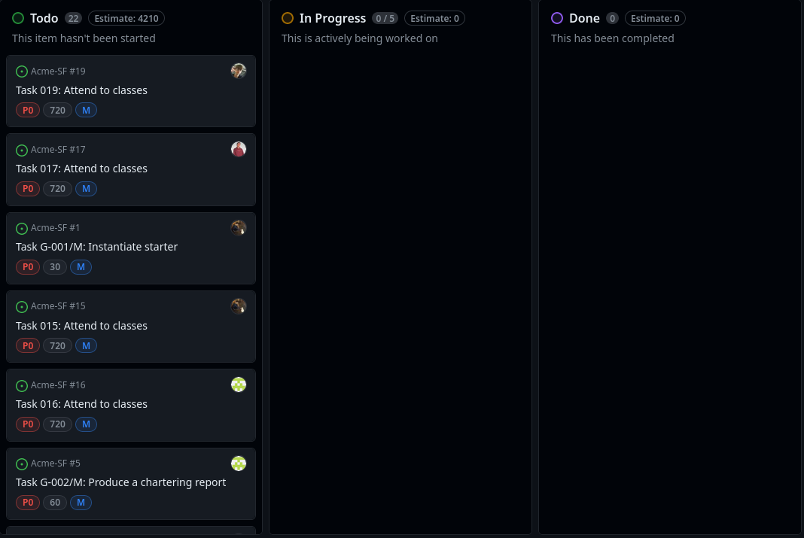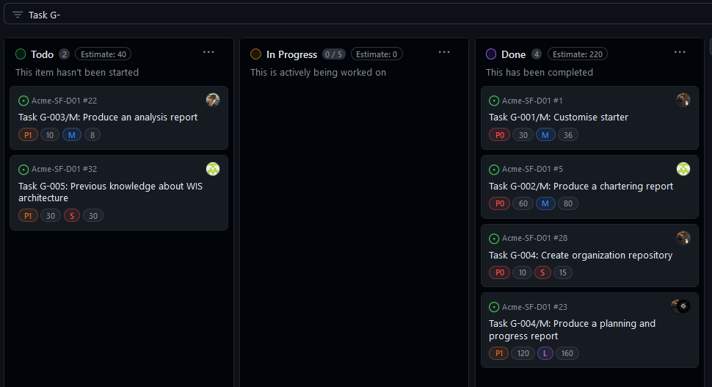

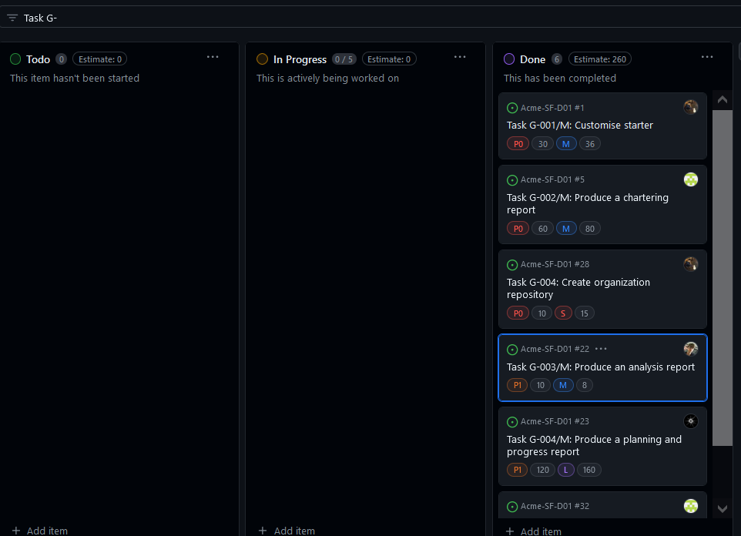

* + Budget

|  |  |  |  |  |  |
| --- | --- | --- | --- | --- | --- |
| **Title** | **Estimate** | **Assignees** | **role** | **€ per hour** | **budget of the task** |
| Task G-005: Previous knowledge about WIS architecture | 30 | alfalolan | developer | 20 | 10€ |
| Task G-002/M: Produce a chartering report | 60 | alfalolan | developer | 20 | 20€ |
| Task G-004: Create organization repository | 10 | Pablo-Caballero-Maria | manager | 30 | 5€ |
| Task G-004/M: Produce a planning and progress report | 120 | JuanGarciaCarballo | developer | 20 | 40€ |
| Task G-001/M: Customise starter | 30 | Pablo-Caballero-Maria | manager | 30 | 15€ |
| Task G-003/M: Produce an analysis report | 10 | mimbrero | developer | 20 | 3,33€ |
|  |  |  |  | **TOTAL** | **63,33€** |

Total cost of the equipment: 1000€ + 700€ + 1100€ + 950€ + 650€ = 4400€

Total: 4463,33€

With a lineal amortization in 3 years of 1487,67€ per year.

## Progress

* + Progress records

Juan Garcia Carballo, Ratio:1, is the best value possible, because he has completed all the task assigned.

Marco Antonio Arnáiz Montero: I received a 1 which is the best value because I have completed all my tasks in an effective way.

Caballero María, Pablo: The ratio between the completed tasks and the assigned tasks was 1, meaning that all the tasks were completed.

Alfonso Luis Alonso Lanzarán Performance indicator:1, is the best value possible, because I have completed all the task assigned.

According to the performance indicator specified in the chartering report, this performance is considered “good” for each member, so all of them will be able to choose their roles for the next deliverable.

* + Conflicts

Intentionally blank

* + Real Cost

|  |  |  |  |  |  |
| --- | --- | --- | --- | --- | --- |
| **Title** | **Invested time** | **Assignees** | **role** | **$ per hour** | **budget of the task** |
| Task G-005: Previous knowledge about WIS architecture | 50 | alfalolan | developer | 20 | 16,67€ |
| Task G-002/M: Produce a chartering report | 80 | alfalolan | developer | 20 | 26,67€ |
| Task G-004: Create organization repository | 15 | Pablo-Caballero-Maria | manager | 30 | 7,5€ |
| Task G-004/M: Produce a planning and progress report | 160 | JuanGarciaCarballo | developer | 20 | 53,33€ |
| Task G-001/M: Customise starter | 36 | Pablo-Caballero-Maria | manager | 30 | 18€ |
| Task G-003/M: Produce an analysis report | 8 | mimbrero | developer | 20 | 2,67€ |
|  |  |  |  | **TOTAL** | **81,5€** |

Total cost of the equipment: 1000€ + 700€ + 1100€ + 950€ + 650€ = 4400€

Total: 4481,50€

With a lineal amortization in 3 years of 1493,83€ per year.

# Conclusions

Summary:

The Acme-SF project, in its initial stages, established the repository and made minor changes. The report focuses on technology familiarization, workspace setup, WIS requirements analysis, and documentation.

The real cost is 4481,50€, with an annual amortization of 1493,83€. Despite financial considerations, the team's efficient documentation work sets a foundation for future stages.

In conclusion, the first deliverable demanded quick adaptation but laid the groundwork for efficient work in subsequent project stages.

Bibliography

Intentionally blank